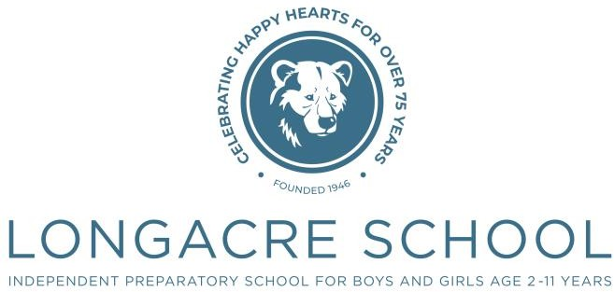

Nursery

Term Dates 2024-2025

**Michaelmas Term 2024**

|  |  |
| --- | --- |
| Term Ends | Friday 20th December |

**Lent Term 2025**

|  |  |
| --- | --- |
| Term Begins | Friday 3rd January |
| Term Ends | Thursday 17th April |

**Summer Term 2025**

|  |  |
| --- | --- |
| Staff INSET | Tuesday 22nd and Wednesday 23rd April |
| Term Begins | Thursday 24th April |
| Term Ends | Friday 15th August |

**Michaelmas Term 2025**

|  |  |
| --- | --- |
| Staff INSET | Monday 1st, Tuesday 2nd, Wednesday 3rd September |
| Term Begins | Thursday 4th September |